Tool Holder Cleaning SOP

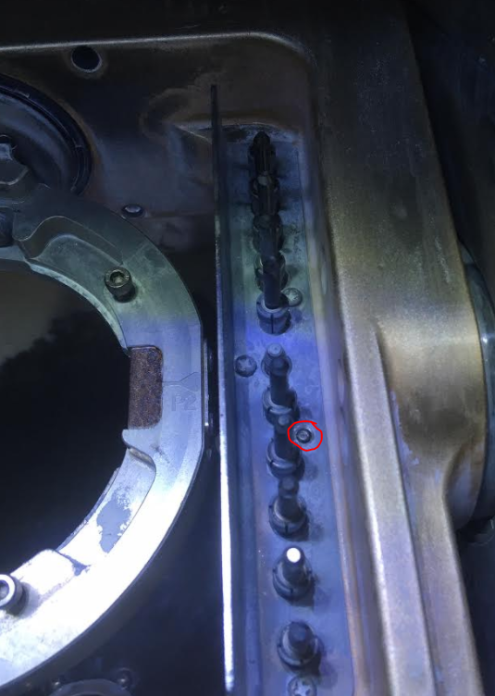

This maintenance is meant to extend the life of the tool holders on the Versamill 5x400s.

Each mill will require disassembly of the tool holder semiannually (every six months per the Trello Board).

The tool holder is removed by **carefully** unscrewing five phillip head screws. These ferrous screws may break if stressed and may require multiple soaks of significant duration with liquid wrench or equivalent lubricant. WD40 should **not** be used for this purpose unless as a last resort per Axsys tech support.

If a screw is broken during removal, please contact your team lead at your earliest convenience.

Once the screws are removed, **carefully** lift and remove the plate **without hitting the sensor**.

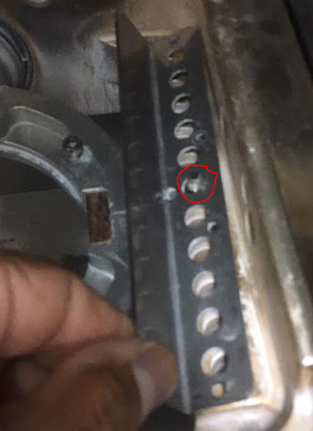

Remove the individual sockets.

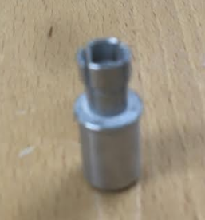 Some of them might be frozen and will require force to remove.

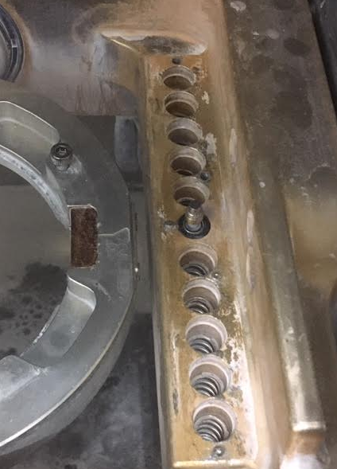

Clean the area and be sure all springs move freely. Report any issues to your supervisor and document your findings in the maintenance log.

Replace any bent sockets with new ones.

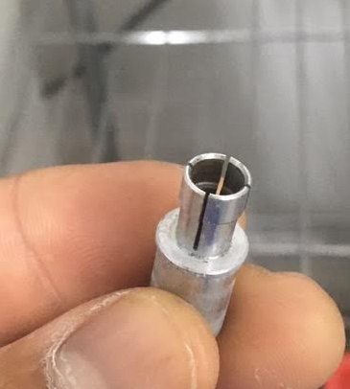

Reassemble and be sure to dab some silicone on each of the screws prior to completion.